|  |
| --- |
| Wipro Technologies |
| Python |
| Installations and Environment Creation |

|  |
| --- |
| Pranay Dutta (INDIA - GIS IIMS)  9-14-2018 |

Index

* Required Software Installations
* Creating Environment and Library Installations
* **Required Software Installations**
* Python.exe (Any version of 3.x 64bit /32 bit)
* Jupyter Notebook
* Jetbrains Pycharm
* MSSQL and/or MySQL Database

Post installation of python 3.x do the below steps

Step 1: **This PC > Properties > Advance System settings > Advance > Environment Variables>**

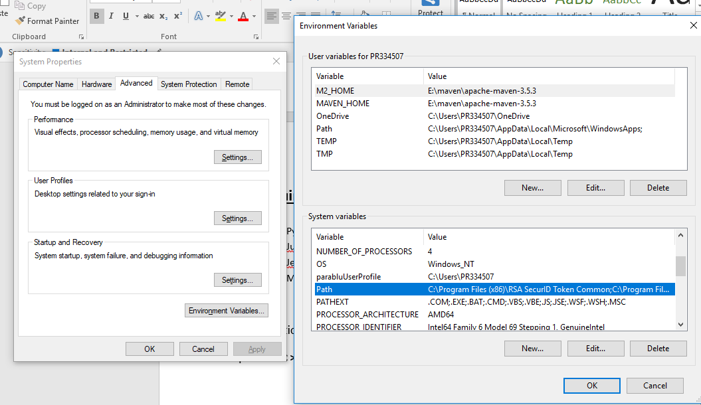

Step 2: Edit Path>

Step 3: Add

1. C:\Users\(AD ID)\AppData\Local\Programs\Python\Python36
2. C:\Users\(AD ID)\AppData\Local\ Programs\Python\Python36\Scripts
3. C:\Users\(AD ID)\AppData\Local\Programs\ anaconda3\Scripts(**if anaconda installed**)

Step 4: Open Command Prompt and check **python** and **pip** is properly installed or not

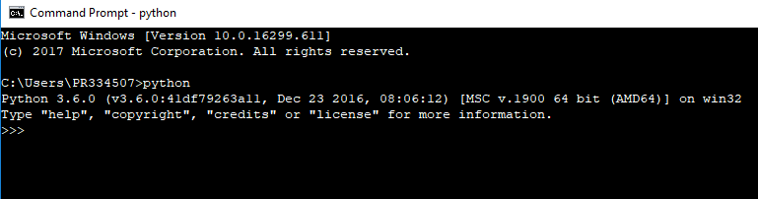

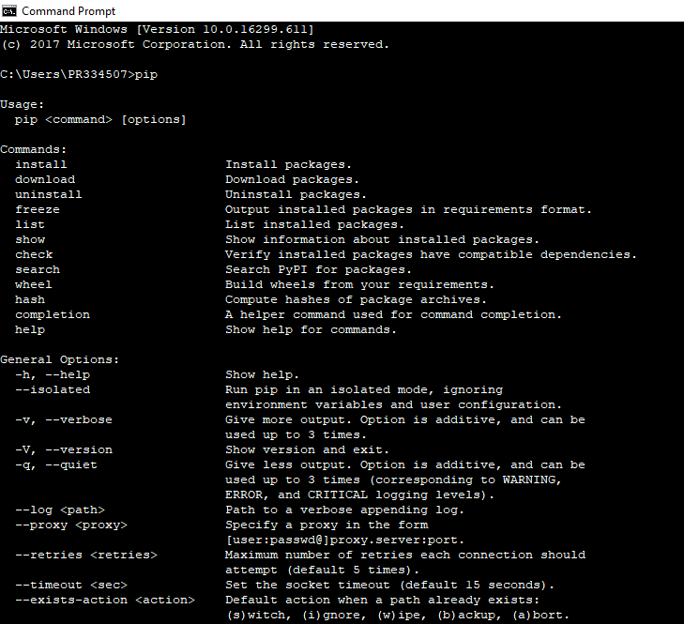

Step 5: cmd > **python -m pip install --upgrade pip**

Step 6: **python -m pip install Jupyter**

Step 7: open Jupyter notebook from Windows search and use it.

Step 8: If Workspace is not in C drive,

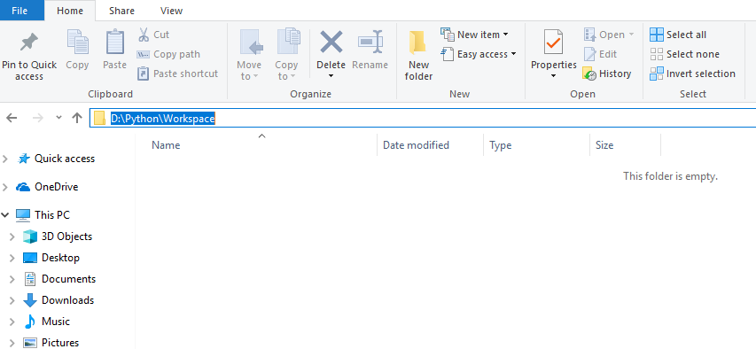

In the address bar type **cmd** > **jupyter notebook**

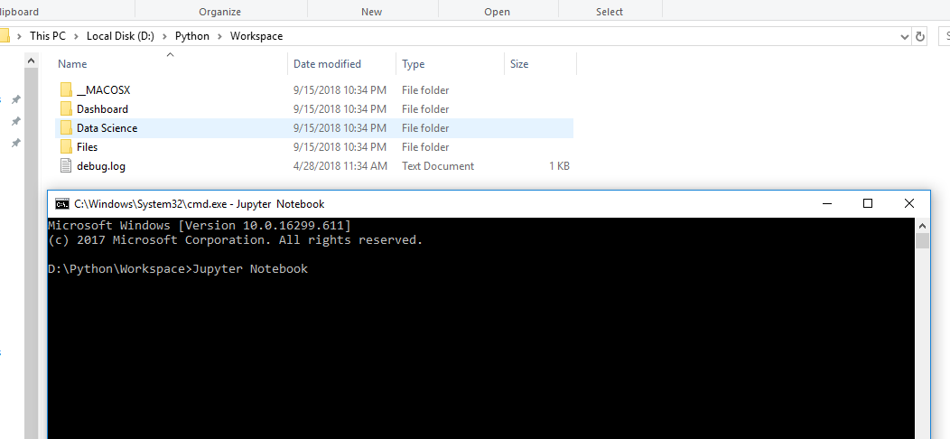

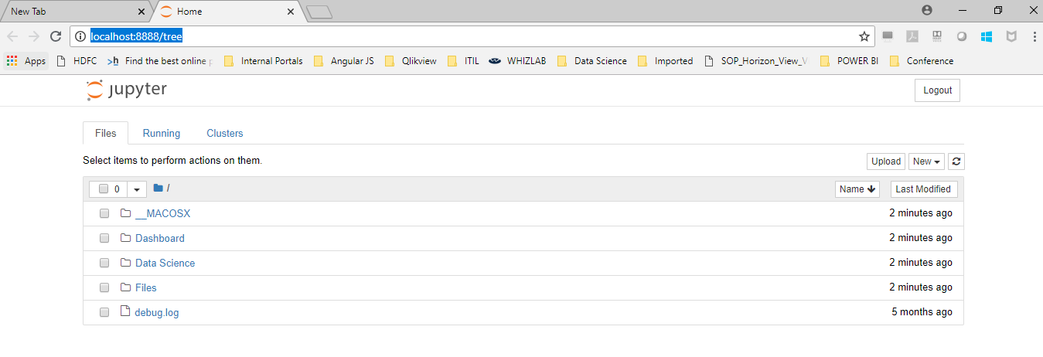

Now , use the jupyter notebook console.

* **Creating Environment and Installing Libraries:**
* To Create Python environment in you local system

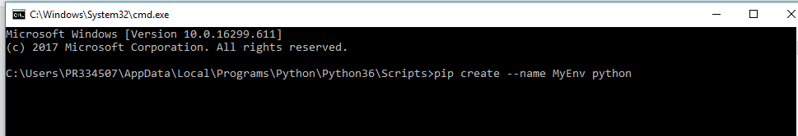

* To activate existing environment

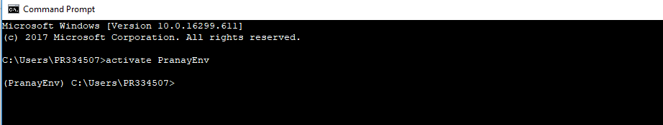

* To install any library online

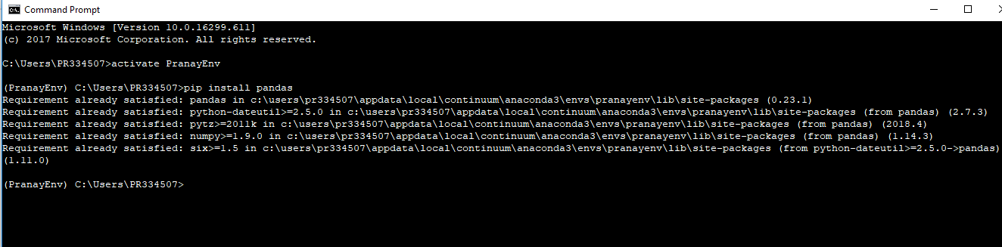

* To install any library offline

<https://www.lfd.uci.edu/~gohlke/pythonlibs/>

visit above link and download python whl file for the proper library and Install the whl files in the below process :

**CMD**>

**C:\Users\PR334507\AppData\Local\Continuum\anaconda3\Scripts\pip install pymssql-2.1.3-cp36-cp36m-win_amd64.whl**